ASR – add delivery classification

Delivery classification :
1. SBD – Same Business Day
2. NBD – Next Business Day
3. NA – Not applicable

Despatch screen:
.We have column for CE receive date and time plus order creation date and time. I will need to add an extra column to have the SBD and NBD. The system need to help to compare both the 2 timings and make result to show SBD or NBD by per line . Take note as long as the dates are of the same day then it will generate out as SBD and if the dates of CE receive are the next day or more days later, system will select NBD.

But pls make sure that the extra column of getting the SBD and NBD must allow us to flip over and change manually if we have to do it also. Let me know by when these changes can be made?

Exception Case:
- Those under CE ID APHUB wont have the CE Receive timing. They’re not using PDA.
->PF: Delivery class will be SBD?
-> Ira: this will not in the billing report, so we will default the delivery classification as ‘APHUB’ (not applicable), CEID = APHUB
- no ePOD update
-> PF: will you perform CErecevied date upload then it will updated the CEReceived date ?
If the date is not available in Report extraction, what should be the system derived Delv classification?
-> Ira: in case no ePOD timestamp available, Ira / admin will update the CE Receive (TIME) and CE Received Date (date) manually in dispatch screen.
Should there’s any missing of CE receive date, system will derive the Delivery Classification as ‘NA’,
Admin should check the billing report for missing CE Received Date and update the Despatch Entry accordingly.

Delivery and Collection Screen:
Delivery Classification to be based on Add Date against Requested delivery date.
If same day then define as SBD else if different date, define as NBD

Changes in IDTS:

- Despatch entry – add delivery Classification
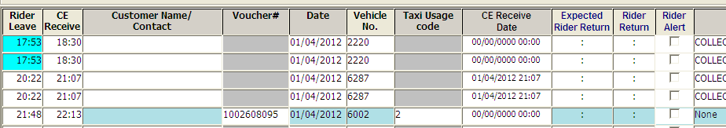
Admin to update CE Receive date,
If there’s no ePOD update.

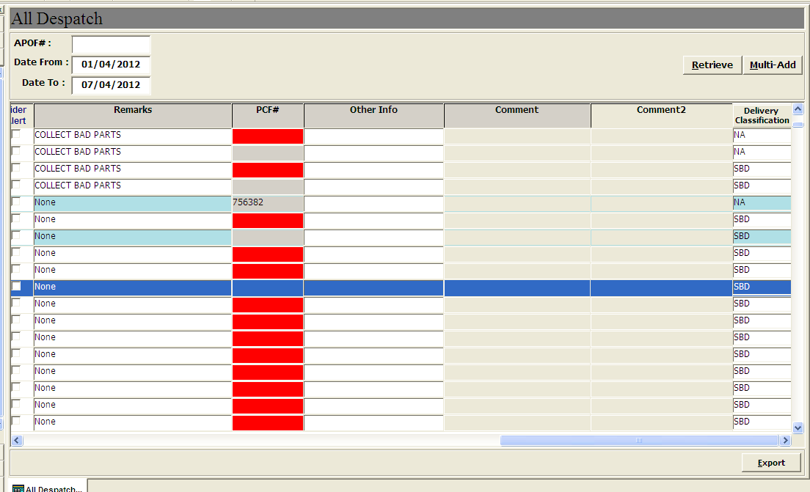

- Delivery - add delivery Classification
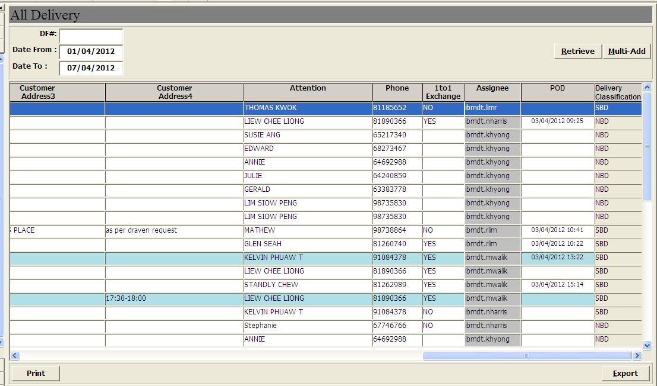
- Collection
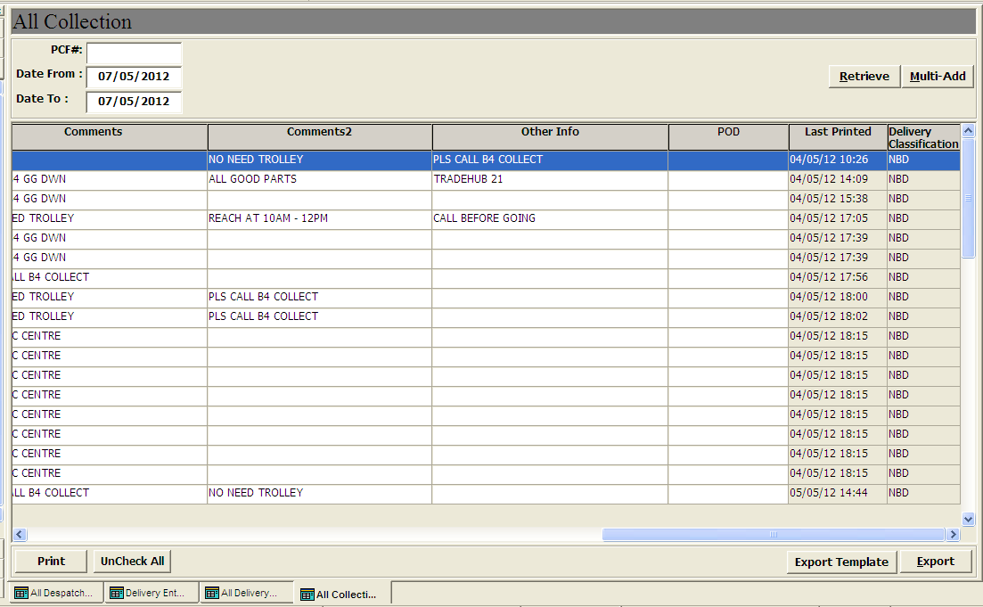

- Reports: Consolidated Trip report by Vendor
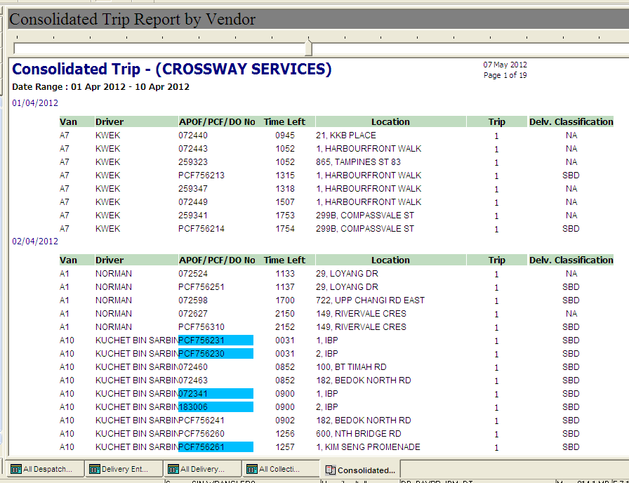

- Reports: Consolidated Trip report to IBM
